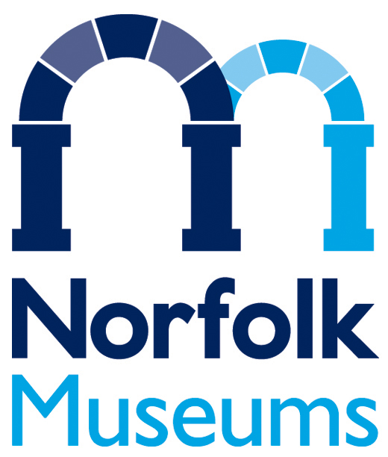
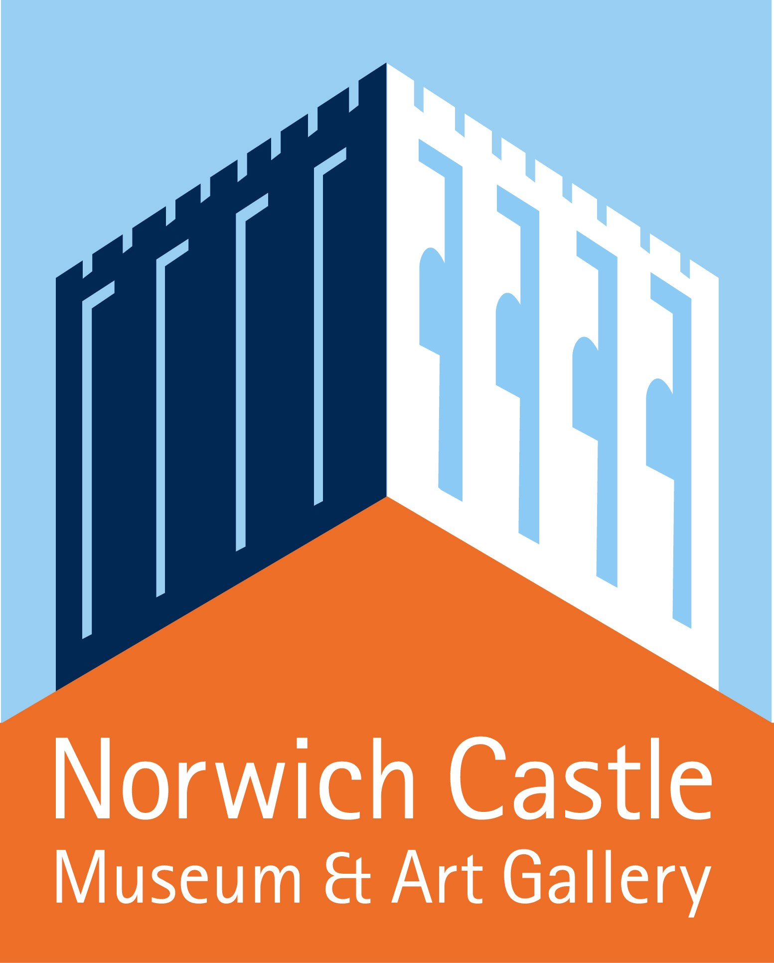
Build Your Own: Tools for Sharing
Norwich Castle Museum & Art Gallery
3 October 2015 – 3 January 2016

A FACT and Crafts Council partnership exhibition in association with Norfolk Museums Service

VISITOR INFORMATION SHEET:

Location: Norwich Castle Museum & Art Gallery, Castle Hill, Norwich NR1 3JU
Tel. +44 (0)1603 495897, www.museums.norfolk.gov.uk

Funding: Arts Council England, Norfolk County Council, East Anglia Art Fund, Norfolk
Contemporary Art Society

Opening Times: Open All Year, Mon-Sat: from 10am–4.30pm, Sun: 1–4.30pm

Open most Bank Holidays (hours as above) except 24, 25 and 26 Dec 2015 and 1 Jan 2016

Admissions: Prices from 1 April 2015 – 31 March 2016:

Castle Ticket (including Special Exhibitions):
Adult: £8.35; Concession*: £7.50; Child (4-18) £6.25
Family: 1 adult + all children: £17.50; 2 adults + all children: £23.50;

Special Exhibitions Ticket only:
Build Your Own: Tools for Sharing: 3 October 2015 – 3 January 2016
Adults: £6; Concession*: £5; Child (4-18 yrs): £4

Pop in for £2 one hour before closing. Also 12 noon-1pm weekdays during school term.
Museums Pass holders, Friends of Norwich Museums and under 4s free.
*Visitors with disabilities, unwaged, over 65s, in full time education.
Visitors with disabilities may bring one companion in free.
Admission to the shop, cafe and Rotunda information desk is free.
Access to Battlements and Dungeons are by guided tours only:
Adult: £2.75; Concession: £2.50; Child (4-18 yrs): £2.10; 1 Adult + all children: £5.80; 2 Adults + all children £7.70

Discounts: Discounts for groups: ring 01603 495897 / 493636 for details.
Holders of Go 4Less Cards and district leisure cards can visit for the discounted price of £4.50
If you travel by Park & Ride show your bus ticket (purchased the same day) to get admission for up to 5 people for just £4.50 each

Related events: The exhibition will be supported by a wide-ranging events programme including talks,
and events days.

Shop: The Castle Shop has a wonderful selection of gifts, toys, books and cards. A new publication Build Your Own with contributions from leading curators and academics will be on sale for £10.

Café: Norwich Castle Café serves a delicious range of hot and cold snacks, drinks and meals. There are special menus for groups.

How to get there: Park and Ride www.passengertransport.norfolk. gov.uk, 0344 800 8020
Public Transport, Traveline, 0871 200 2233
Public Car Parks nearby, SAT NAV: NR1 3JU (Norwich Castle)
Parking for visitors with disabilities, e-mail museums@norfolk.gov.uk, 01603 493625

Access: Most of the museum is accessible to users of mobility scooters and wheelchairs.

For further information and images, please contact:
Amanda Stucklin T: 07789 007780 E: Amanda@stucklin.com OR
Esther Morgan, Relationships Officer, Norfolk Museums Service
T Direct: +44 (0)1603 223215 E: esther.morgan@norfolk.gov.uk [Mon-Wed]
Twitter: @NorfolkMuseums

